The dataset contains the following columns:

* **Series ID**: Unique identifier for each series
* **Title**: Name of the web series
* **Genre**: Genre of the series
* **Platform**: Streaming platform
* **Seasons**: Number of seasons
* **Episodes**: Total number of episodes
* **IMDB Rating**: IMDB rating
* **Year**: Release year

**✅ Task 1: Trend of Web Series Released Per Year**

**Goal**: Visualize the trend of web series released over time using a line chart.

Let's compute and plot this.

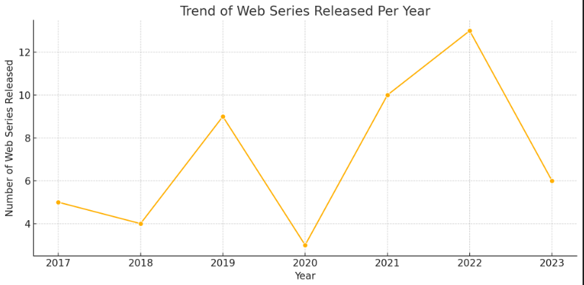

**Task 1 Result: Trend of Web Series Released Per Year**

From the line chart:

* The number of web series released increased significantly in **2021 and 2022**, peaking in 2022.
* There was a notable dip in **2020**, likely due to the COVID-19 pandemic.
* The overall trend shows growth in web series production post-2020.

**✅ Task 2: Distribution of IMDB Ratings Across Streaming Platforms**.

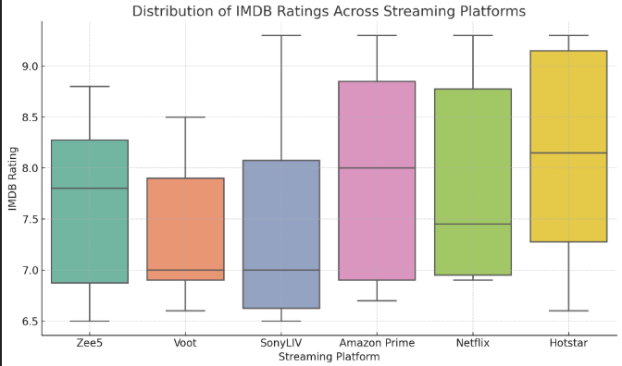

**Task 2 Result: Distribution of IMDB Ratings Across Streaming Platforms**

From the box plot:

* **Amazon Prime** and **Hotstar** tend to have the highest median IMDB ratings.
* **SonyLIV** and **Voot** show lower median ratings.
* **Hotstar** shows the least variability, suggesting consistent quality.
* **Outliers** exist for most platforms, indicating some standout high- or low-rated series.

**✅ Task 3: Top 5 Highest Rated Web Series**.

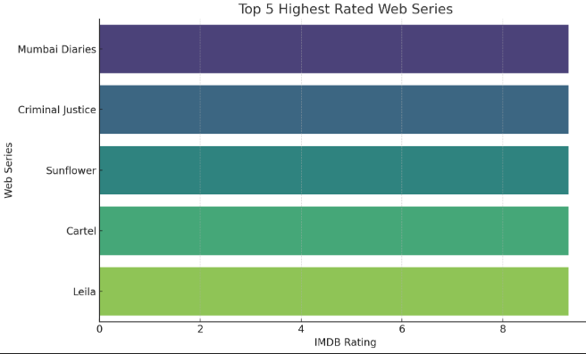

**Task 3 Result: Top 5 Highest Rated Web Series**

All of the following web series have the top IMDB rating of **9.3**:

| **Title** | **Platform** | **Genre** |
| --- | --- | --- |
| Mumbai Diaries | Amazon Prime | Comedy |
| Criminal Justice | Netflix | Mystery |
| Sunflower | SonyLIV | Mystery |
| Cartel | Hotstar | Sci-Fi |
| Leila | Hotstar | Crime |

**✅ Task 4: Genre Distribution of Web Series**.

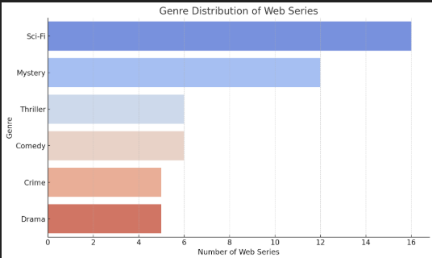

**Task 4 Result: Genre Distribution of Web Series**

* **Sci-Fi** is the most common genre, followed by **Mystery**.
* Other popular genres include **Comedy**, **Thriller**, **Crime**, and **Drama**.
* This indicates a strong preference for speculative and suspenseful content.

**✅ Task 5: Relationship Between Number of Episodes and IMDB Rating**.

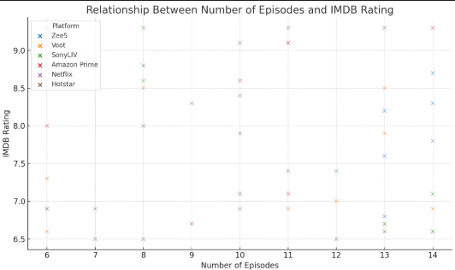

**Task 5 Result: Relationship Between Number of Episodes and IMDB Rating**

* There's **no strong linear correlation** between the number of episodes and IMDB rating.
* Web series with both low and high episode counts have received high ratings.
* Some platforms (e.g., **Amazon Prime**, **Hotstar**) have high-rated series even with moderate episode counts.

**✅ Task 6: Platform-Wise Average IMDB Rating by Genre (Heatmap)**.

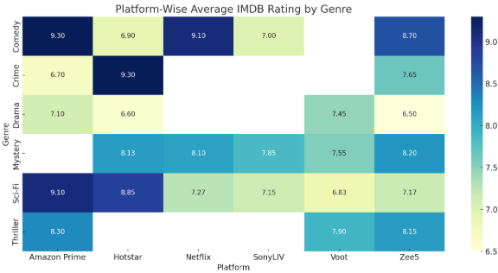

**Task 6 Result: Platform-Wise Average IMDB Rating by Genre (Heatmap)**

Key insights from the heatmap:

* **Amazon Prime** excels in **Comedy** and **Sci-Fi** genres (both with 9.1+ average).
* **Hotstar** performs strongly in **Crime** (9.3) and **Sci-Fi** (8.85).
* **Mystery** shows consistently high ratings across most platforms.
* **Drama** tends to have lower average ratings overall.

**✅ Task 7: Episodes Per Season Analysis**.

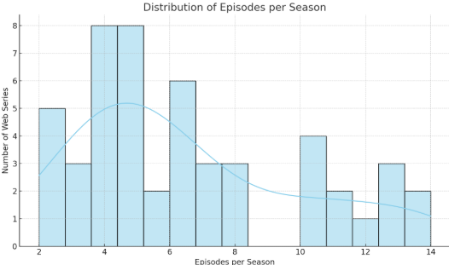

**Task 7 Result: Episodes Per Season Analysis**

* Most web series have **4 to 6 episodes per season**.
* A few have longer seasons (10–14 episodes), but these are less common.
* The average number of episodes per season appears to be around **5**.

**✅ Task 8: IMDB Rating vs. Number of Seasons (Grouped by Platform)**.

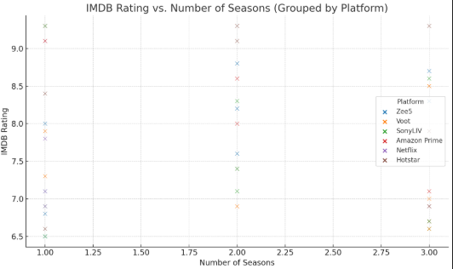

**Task 8 Result: IMDB Rating vs. Number of Seasons (Grouped by Platform)**

* No strong trend between the number of seasons and IMDB rating.
* Platforms like **Hotstar** and **Amazon Prime** have high-rated series even with multiple seasons.
* Most series have 1 or 2 seasons; very few go beyond that.

**✅ Task 9: Identify the Most Consistent Genre in Ratings**.

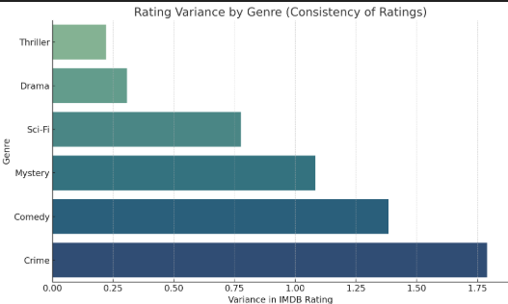

**✅ Task 9: Highlight – Most Consistent Genres in IMDB Ratings**

The bar chart above shows **variance in IMDB ratings** by genre, with the **most consistent genres highlighted in green** (lowest variance):

**Key Insights:**

* **Thriller** and **Drama** are the **most consistent genres**, indicating stable audience reception.
* **Crime** has the highest variance, meaning ratings in this genre vary significantly across different web series.
* A lower bar (variance) = more consistent viewer reception.

**✅** Task 10 : Highlight Web Series with Above-Average Ratings in Each Genre

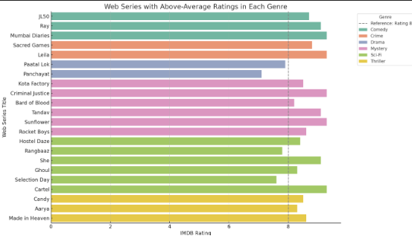

**Chart Highlights:**

* **Each bar** represents a web series that scored higher than its genre's average rating.
* **Color-coded by genre**, helping you identify which genres consistently outperform.
* The **dashed line at rating 8** serves as a visual reference point.